Contents

Background 1
Enabling the External Users widget 1
Creating an External User 3
Managing an External User 4
Set Authentication Type 5
Assign Menu Profiles 5
Deleting an External User 6

Background

The External Users widget is a widget within the CorePortal Security Dashboard. Enabling this widget will allow us to create Portal accounts for users who do not have an employee record in CoreHR. Specifically, it will allow us to provide members of the Access Group with Portal accounts, so that they can provide better support to the University with incidents, problems and projects.

Enabling the External Users widget

Navigate to: CorePortal > Security > Menu Profiles

From the Search bar at the top of the screen, navigate to the Security dashboard, and select the Menu Profiles tab from the sidebar menu:

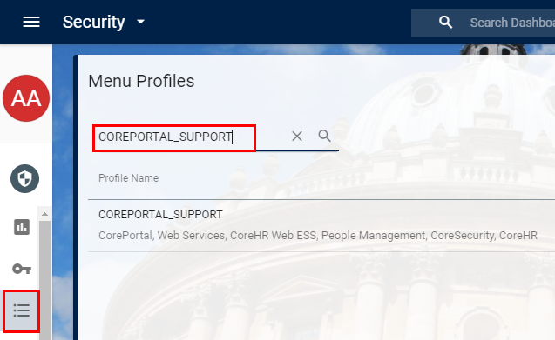
Search for the menu profile “COREPORTAL_SUPPORT”. When it appears, click the three dots on the right and select “Manage Menu Options”:

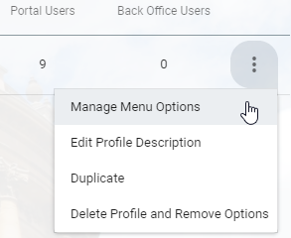

The Menu Options screen will open. Search for keyword “External” and enable the following options:

- Create External
- Delete External
- External User Creation
- Get External

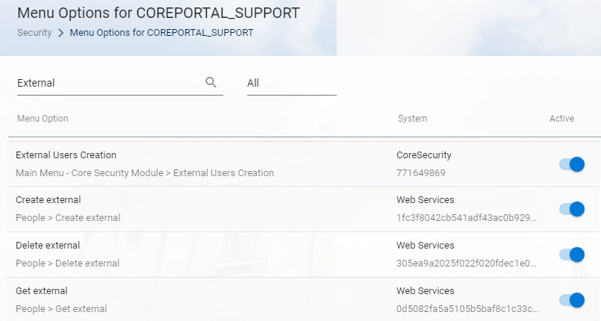

Changes are saved automatically.

Creating an External User

Navigate to: CorePortal > Security > User Management

From the Search bar at the top of the screen, navigate to the Security dashboard, and select the User Management tab from the sidebar menu. Scroll down the screen to the External Users widget and click “Create External User”:

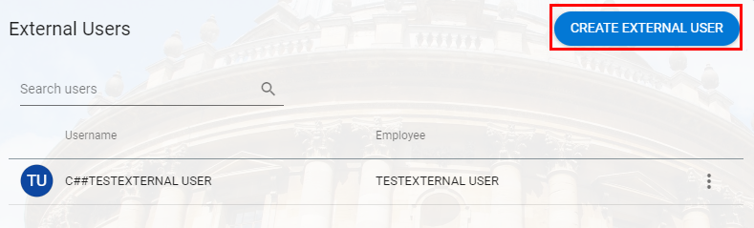

The Add External User window will pop up. Complete all the fields provided, and note that you will have choose the username and password yourself.

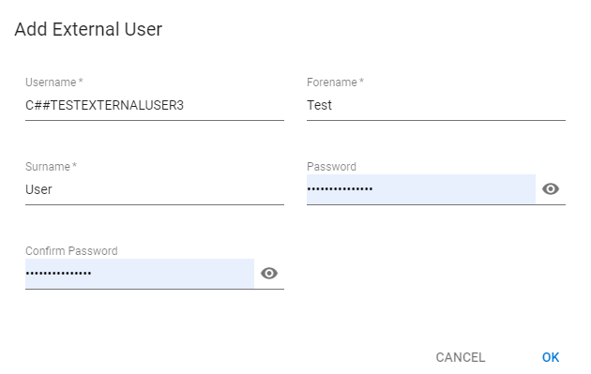

 | NB: The Access Group (previously CoreHR) have historically had usernames prefixed with “C##”, so maintain this naming convention for any external accounts you create for Access Group representatives.

Click “OK” to save your changes. The newly-created user will appear in the External Users widget:

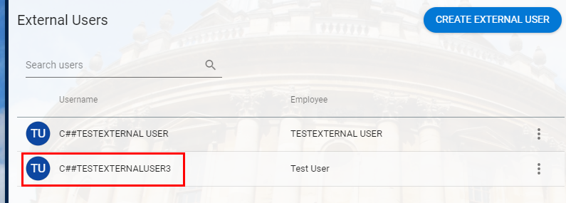

Managing an External User

Navigate to: CorePortal > Security > User Management

From the Search bar at the top of the screen, navigate to the Security dashboard, and select the User Management tab from the sidebar menu. Scroll down the screen to the System Users widget and search for the username of the external user you wish to manage:

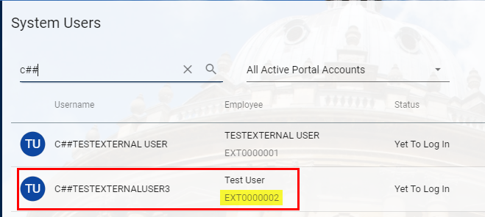

 | NB: External users are automatically granted employee numbers linked to their usernames. External user employee records are all prefixed with “EXT”, as in the image above (EXT00000001, EXT00000002, etc.). If you know your external user’s EXT number, you can search for that instead of the username.
Select the user record and click the three dots on the right to open the sub-menu. Select “Manage Account”:

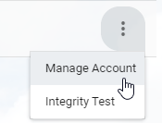

The Manage Portal Account screen will open. Here, the external user account can be managed in the same way as any other Portal account.

Set Authentication Type

Select the General tab from the sidebar menu. Under the Security heading, click Authentication Type and select “LDAP - Active Directory Authentication” from the drop-down menu. This will allow the external user to access CorePortal via the SSO WebAuth login screen:

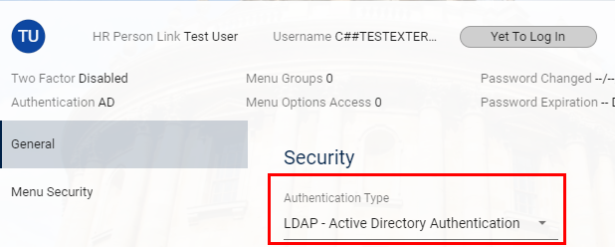

Assign Menu Profiles

Select the Menu Security tab from the sidebar menu. A list of available menu profiles will appear. You can search for a specific profile, or choose to see only Active or Inactive profiles using the drop-down list next to the Search box:

To assign a menu profile to a user, or to remove a menu profile which is currently assigned to a user, simply toggle the Active indicator on the profile record. An active profile has a blue indicator, while an inactive profile has a pale white indicator:

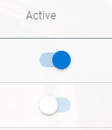

Your changes will be saved automatically and a message will appear on the screen confirming this:

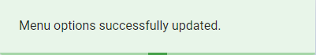

Deleting an External User

Navigate to: CorePortal > Security > User Management

From the Search bar at the top of the screen, navigate to the Security dashboard, and select the User Management tab from the sidebar menu. Scroll down the screen to the External Users widget.

Select the external user you wish to delete and click the three dots on the right to open the sub-menu. Select “Drop/Delete Account”:

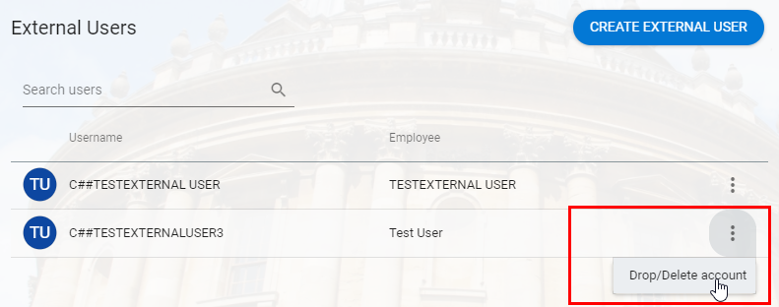

A warning message will appear. If you are certain you wish to delete the account, click “Yes”:

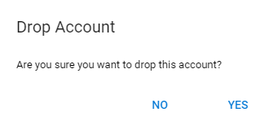

The screen will refresh and the external user will disappear from the External Users widget. Their username and EXT number have both now been deleted from the database.

